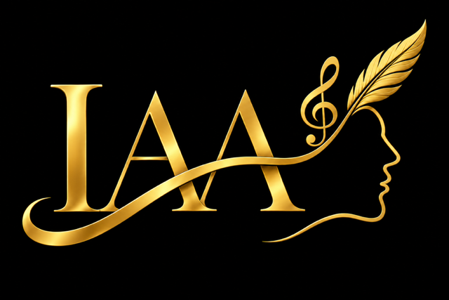  Creative Business Basics Check-In  A simple snapshot of where your creative work stands today. | 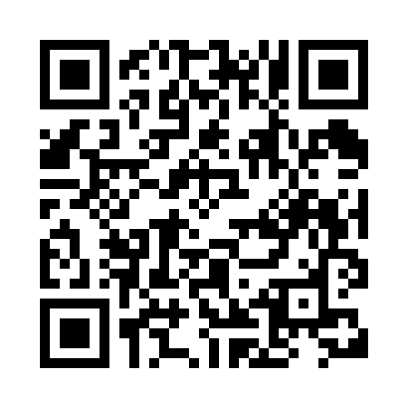  Scan for IAA website
Name: [ Type your name ]
Creative field or work: [ What do you create? ]
Business or project name (if any): [ Type a name or leave blank ]
Date: [ Enter the date ]

1. Is your creative work a hobby or a business?
☐ It is a hobby for me right now.
☐ I am thinking about turning it into a business.
☐ I treat it as a business and earn money from it sometimes.
☐ I treat it as a business and earn money from it regularly.
How long have you sold your creative work? [ Not yet, 6 months, 3 years ]

2. A few business basics
Have you registered your business? ☐ Yes ☐ No ☐ In progress ☐ Not sure
If yes, what type of business and about what year? [ Type the type and year, if known ]
Do you have an EIN (federal business tax ID)? ☐ Yes ☐ No ☐ In progress ☐ Not sure
Do you have a separate bank account for the business? ☐ Yes ☐ No ☐ In progress ☐ Not sure
Do you keep track of business income and expenses? ☐ Yes ☐ No ☐ Sometimes ☐ Need help
Do you know if your work needs a license or permit? ☐ Yes ☐ No ☐ Not sure ☐ Does not apply

3. What would help you move forward?
☐ Choosing a business name or registering my business
☐ Getting an EIN or opening a separate bank account
☐ Pricing my work or finding customers
☐ Keeping track of income and expenses
☐ Marketing, selling, or sharing my work
☐ I have another question or need:
Tell us briefly: [ Type a few words ]

4. One next step
One thing I would like to do next: [ Write one small next step ]
When I hope to do it: [ Enter a date or timeframe ]

